How to Input Accounting Codes
UCSB Physics Department · Purchasing Cheat Sheet

1. Determine if the Account Is a Project or GL
Account codes come to you in different ways and formats. To tell whether yours is a GL or Project account, check the code itself for letters.

Quick check — read the code itself
- Any letter appears anywhere in the code → it's a PROJECT account
- The code is entirely numbers, no letters at all → it's a GL account

Example | Result
1811.19900.2413001.000000.68.000.0000000.101055.00000 | All numbers → GL account
1811-20701-2413002-000000-44-000-E100588-000000-00000 | Contains letters (E100588) → Project account
Ent (4): 1811  Fund (5): 20001  FRU (7): 2413002  Acct (6): 30100000  Purp (2): 44  Prog (3): 000  Proj (7): E002065  Act (6): 000000  Commit (5): 00000 | Contains letters (E002065) → Project account
Note: the code you're given may not always have the same number of segments — the letter rule still applies regardless of length.

2. Entering Accounting Codes in Gateway

Step 1 — Navigate to your Gateway cart and click “Finalize Cart.”
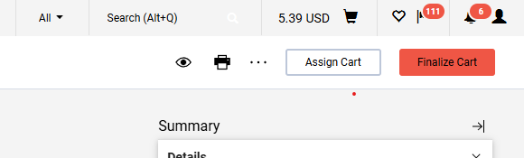

Step 2 — Click the pencil icon in the corner to begin entering accounting codes.
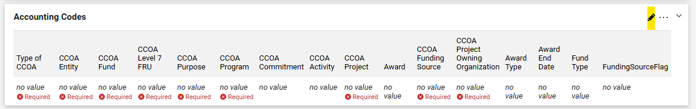

Step 3 — Click “Type of CCOA” and choose GL or Project. (If you're not sure which one applies, revisit Section 1 above.)

GL Accounts

GL Account

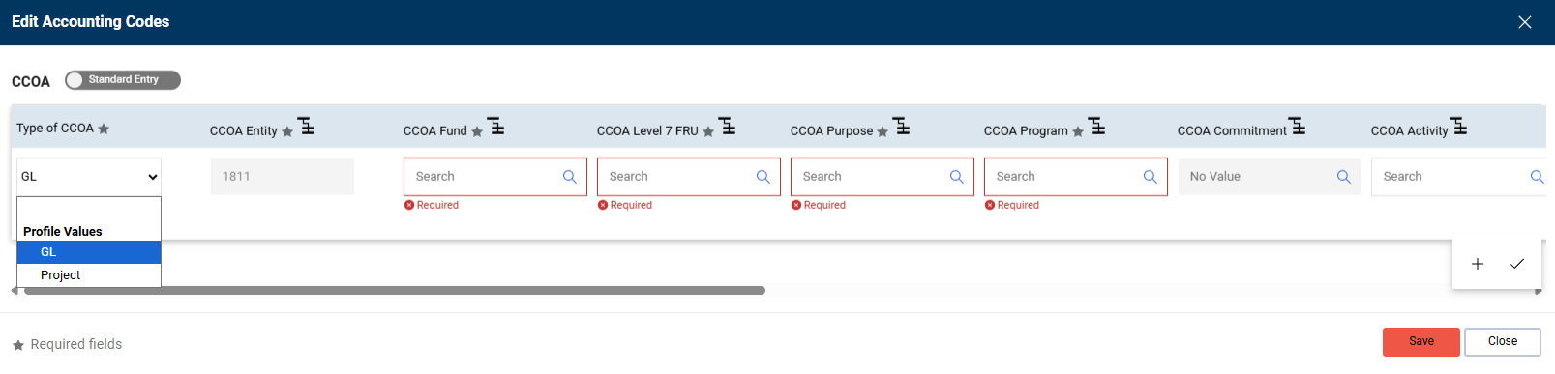
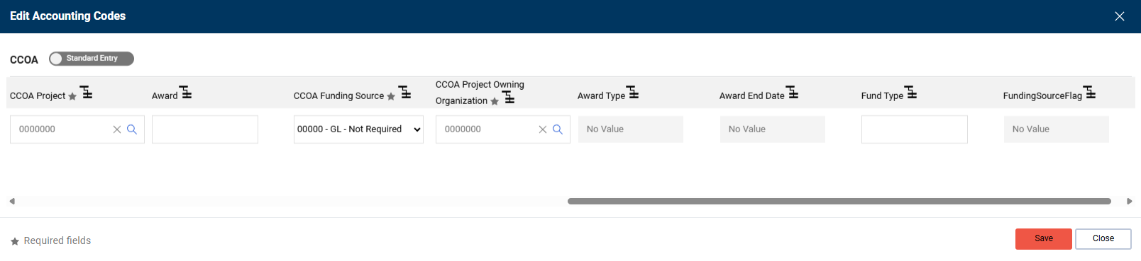
- Fill in CCOA Fund
- Fill in CCOA Level 7 FRU
- Fill in CCOA Purpose (if no purpose code is listed for your account, use the purpose code lookup resource)
- Fill in CCOA Program (if none is listed, use “000”)
- Enter CCOA Activity if your account has an activity code
- Click “Save”

Project Accounts

Project Account

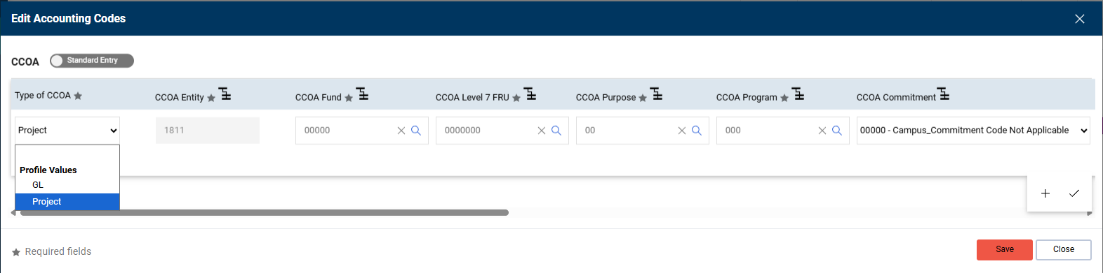
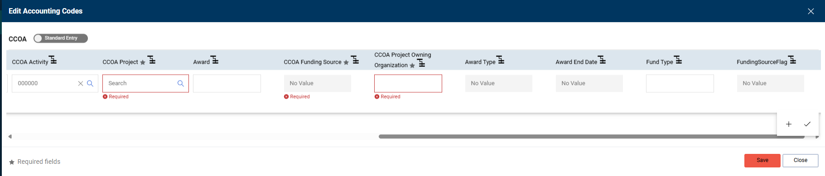
- Fill in CCOA Project — most remaining fields will auto-populate
- Enter CCOA Activity if your account has an activity code
- Click “Save”

