Placing an Order on Gateway
UCSB Physics Department · Purchasing Cheat Sheet
 | Start
● Navigate to the Gateway homepage
↓

 | Vendor type — three paths
  ● Click the company icon  ● Hosted catalog opens  ● Add items, check out  ● Auto-redirects to Gateway  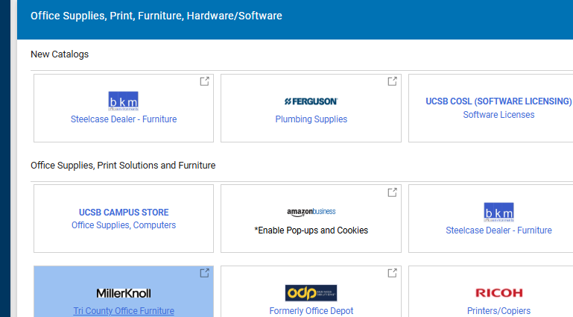 |   ● Click “Non-catalog Item”  ● Look up supplier  ● Enter product, catalog number, quantity, price, packaging  ● Save & go to cart  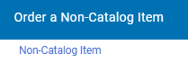 | 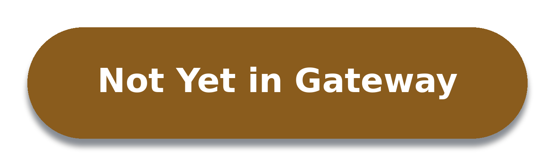  ● Select “New Supplier Request Form”  ● Download & send vendor the Business Information Form  ● Vendor returns it, plus W-9/W-8BEN, invoice, voided check/bank letter (ACH)  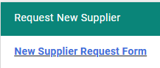

If the vendor… | Then…
Returns paperwork / accepts our terms | Fill out the New Supplier Request Form with their documents → vendor added to Gateway → continue as Non-catalog Item.
Doesn't / credit card only | Use Flexcard Authorization instead: add supplier & contact info, description, part #, quantity, price, and a quote → add to cart.
— all three paths continue below —
↓

If not redirected: sidebar → My Carts and Orders → View Carts → open cart
 | Finalize
● Click “Finalize Cart” (top right) —
● Accounting Codes → pencil icon → enter GL or project CCOA code

Before you submit
✓ Each charge/item is on its own line
✓ Accounting codes entered, no errors showing
✓ Quote attached (skip for punchout)
✓ Shipping/handling/tariff added
↓


 | What happens next — purchasing office
1. Order prepped (0–1 business days typically; up to 2 at peak times)
2. Submitted for approval
3. Routes through: Purchasing → Finance → PI → other campus offices if needed
4. PO generated once approved
→ Standard order → sent to vendor automatically
→ Flexcard order → placed directly by purchasing in the order they are received
5. Vendor ships the order
6. Received & checked in by purchasing
7. You're notified — ready for pickup
UCSB Physics Department · Purchasing Cheat Sheet

