Magnetic Fields of Coils

Equipment

 | Included:
1 | Helmholtz Coil Base | EM-6715
2 | Field Coil (500-Turn) | EM-6723
1 | Primary and Secondary Coils | SE-8653
1 | Patch Cords (set of 5) | SE-9750
1 | Patch Cords (set of 5) | SE-9751
1 | 60 cm Optics Bench | OS-8541
1 | Dynamics Track Mount | CI-6692
1 | 20 g hooked mass (Hooked Mass Set) | SE-8759
1 | Small Round Base (Set of 2) | ME-8974A
2 | 25 cm Steel Rod | ME-8988
1 | Optics Bench Rod Clamps (Set of 2) | OS-8479
1 | 2-Axis Magnetic Field Sensor | PS-2162
1 | Rotary Motion Sensor | PS-2120
Required, but not included:
1 | 850 Universal Interface | UI-5000
1 | PASCO Capstone Software | UI-5400

Introduction

The magnetic fields of various coils are plotted versus position as the Magnetic Field Sensor is passed through the coils, guided by a track. The position is recorded by a string attached to the Magnetic Field Sensor that passes over the Rotary Motion Sensor pulley to a hanging mass.

It is particularly interesting to compare the field from Helmholtz coils at the proper separation of the coil radius to the field from coils separated at less than or more than the coil radius. The magnetic field inside a solenoid can be examined in both the radial and axial directions.

R
x

Theory

Single Coil

For a coil of wire having radius R and N turns of wire, the magnetic field along the perpendicular axis through the center of the coil is given by

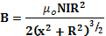 (1)
Figure 1: Single Coil

Two Coils
Figure 2: Two Coils with Arbitrary Separation
R
R
d
x
B₁ B₂
x

R
x

R
R
For two coils, the total magnetic field is the sum of the magnetic fields from each of the coils. On the axis we have:

B = B₁ + B₂

B = (μ₀NIR²/2){[(x-d/2) ² + R²] ^{-3/2} + [(x+d/2) ² + R²] ^{-3/2} }
(2)
where x is measured from the geometric center as shown in Figure 2.
Figure 3: Helmholtz Coils

For Helmholtz coils, the coil separation (d) equals the radius (R) of the coils. This coil separation gives a uniform magnetic field between the coils. Plugging in x = 0 gives the magnetic field at a point on the x-axis centered between the two coils:

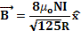 (3)

Solenoid

For a long solenoid with n turns per unit length, the magnetic field is . (4)
The direction of the field is straight down the axis of the solenoid.
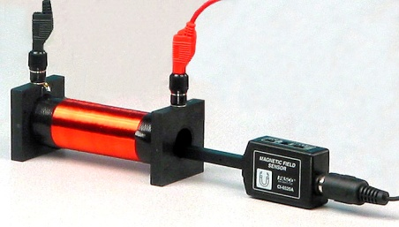

Figure 3A: Solenoid
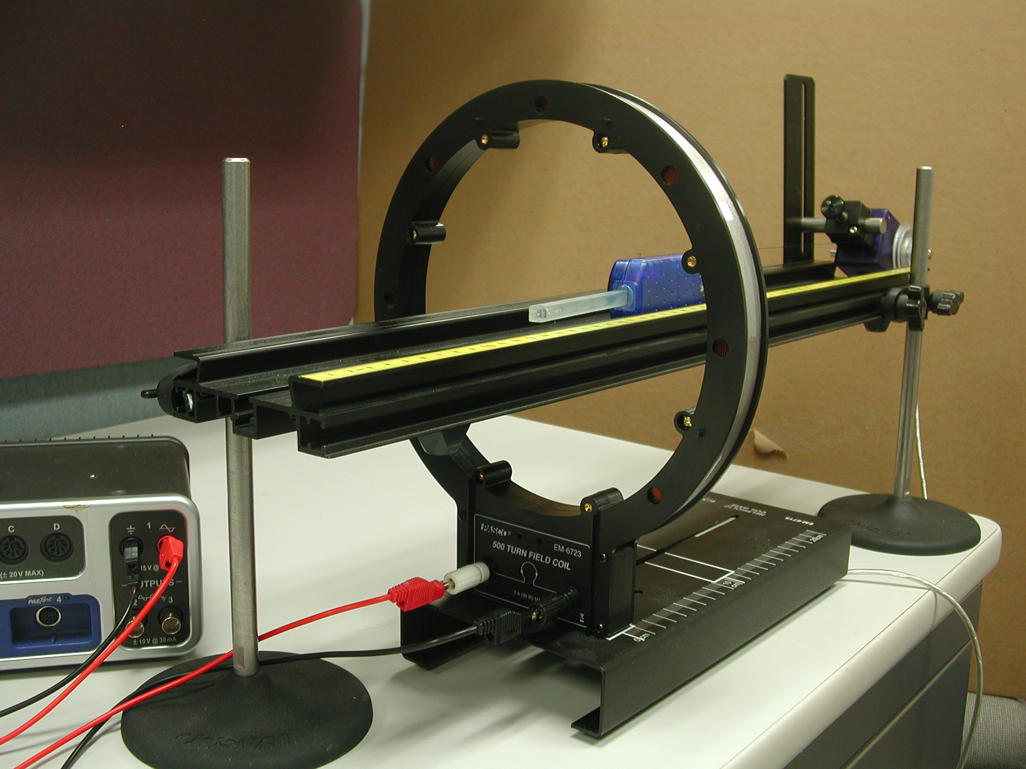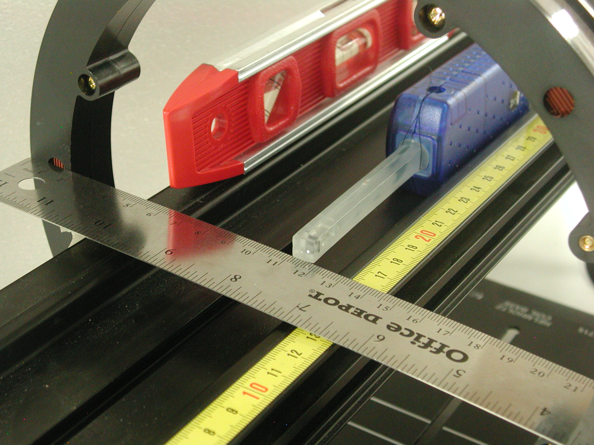
Figure 4: Single Coil Setup Figure 5: Finding the Coil Center

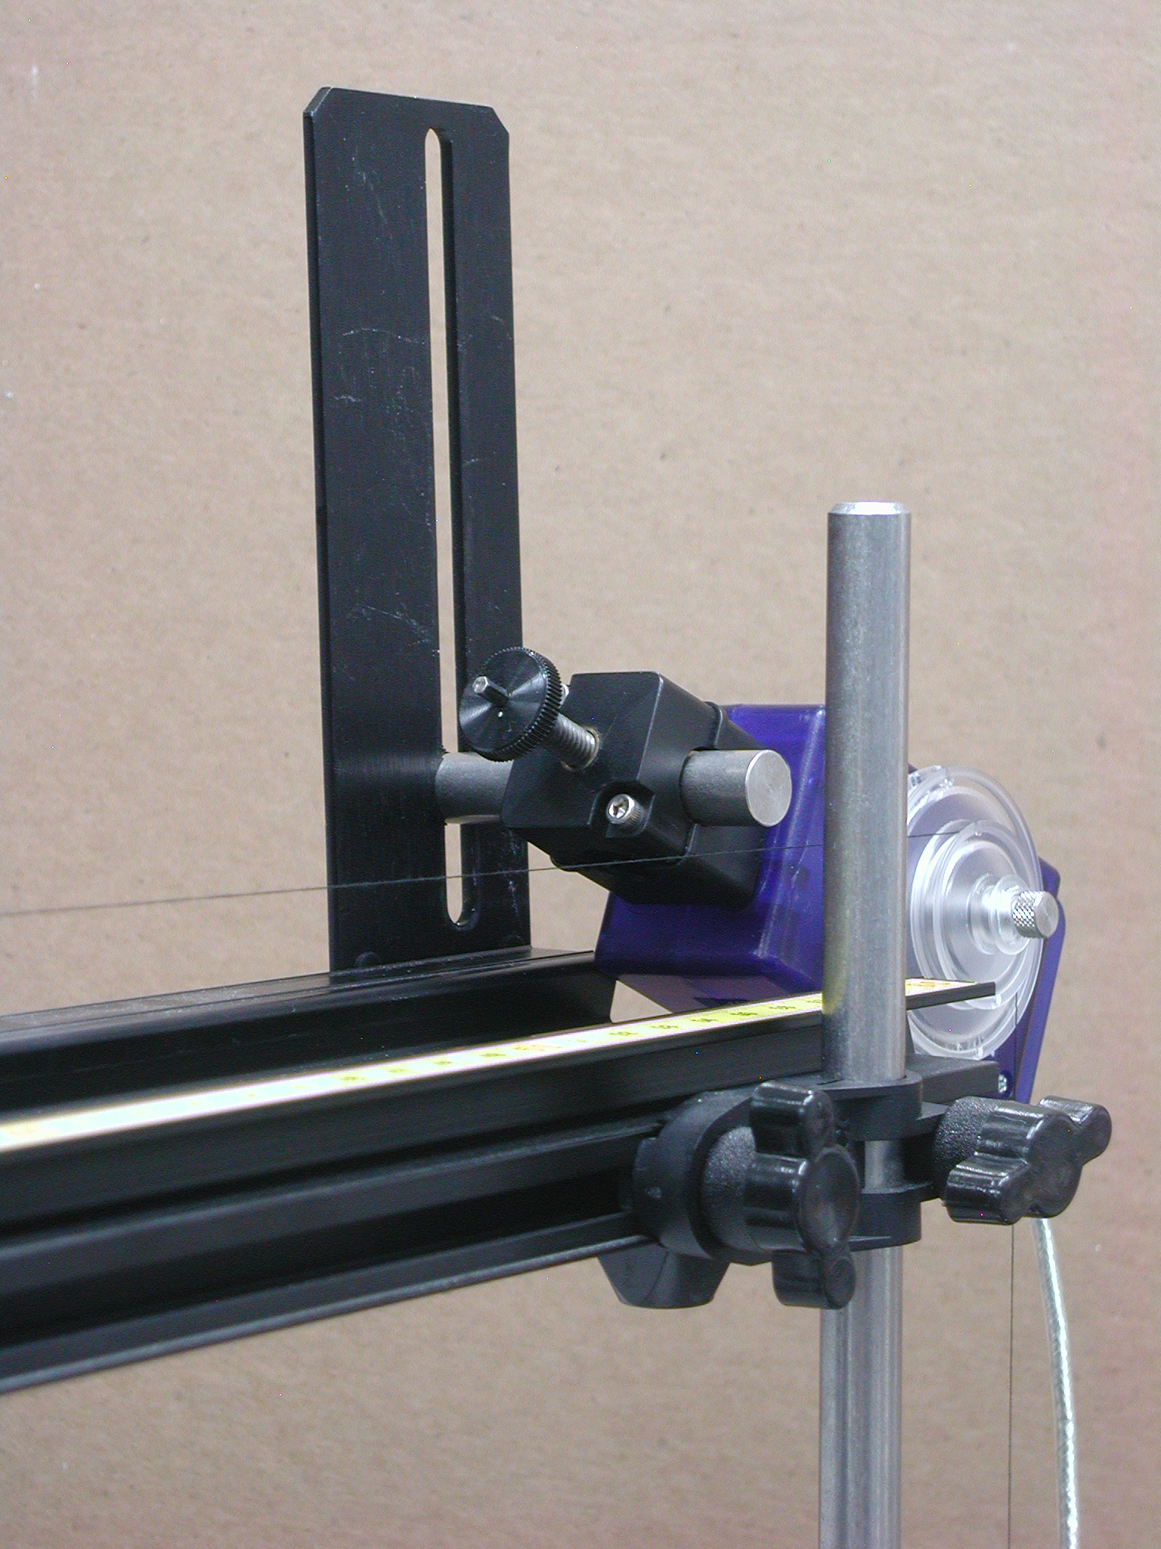 Figure 6: RMS Setup

Setup

- Attach a single coil to the Helmholtz Base so it is aligned with the white rectangle on the base and thus perpendicular to the base. Connect Output #1 of the 850 Universal Interface directly across the coil as shown in Figure 4.

- Pass the optics track through the coil and support the two ends of the track with the support rods. One end of the optics track should be close to the edge of the table so when you hang a mass over the Rotary Motion Sensor, it will hang freely over the edge of the table.

- Level the track and adjust the height so the Magnetic Field Sensor probe will pass through the center of the coil when it is pushed along the surface of the track against the side with the yellow metric scale. An accurate way to do this is shown in Figure 5. The coil diameter is 23.4 cm. The height is adjusted (while maintaining level) so that a thin metric ruler lies just below the holes in the side of the coil holder and 0 cm is at the edge of the coil. The track is adjusted so that the white dot marking the axial sensor is at the 11.7 cm mark. The bottom of the sensor probe is even with the ruler. The coil base needs to be parallel with the optics track. Note that the coil is 2 cm wide, so the exact coil center is 1 cm from the edge of the ruler (at 17 cm in Figure 5). When the white dot on the side of the magnetic probe is at this point (17 cm on the yellow scale in Figure 5), the sensor is very close to the coil center.

- Attach the Rotary Motion Sensor to the track using the bracket as in Figure 6. Cut a piece of thread long enough to reach from the floor to the track. Tie a loop in one end of the thread and slide the sensor probe of the Magnetic Field Sensor through it (see Figure 5). Pass the other end of the thread over the middle step of the Rotary Motion Sensor pulley and attach the 20-g mass. Place the Magnetic Field Sensor against the side of the track with the yellow scale and adjust the position of the Rotary Motion Sensor so the thread is aligned with the middle step pulley.

- Plug the Magnetic Field Sensor and the Rotary Motion Sensor into any two of the PasPort inputs on the 850 Universal Interface.

Single Coil Procedure

- Find the radius of the coil by measuring the diameter from the center of the windings on one side across to the center of the windings on the other side. Enter the value in the Coil Properties table on the Analysis 1 page.

- Slide the Magnetic Field Sensor along the track until the probe sensor is in the middle of the coil (see the italicized note on the previous page). Press the tare button on the Magnetic Field Sensor. Click on Data Summary at the left of the page. Open the properties of the Rotary Motion Sensor (RMS) by clicking on the gear symbol to the right of the Rotary Motion Sensor label. De-select “Zero Sensor Measurement at Start”. Click on "Zero Sensor Now". This will make zero on the x-axis be at the center of the coil. Click OK. Click Data Summary to close the panel.

- Slide the Magnetic Field Sensor back away from the coil until it is about 15 cm from the coil.

- Click on Signal Generator at the left of the screen. Verify that the DC voltage is set to 15 V and click On.

- Click RECORD and slowly move the Magnetic Field Sensor along the track, keeping it against the side with the yellow scale, until the end of the sensor is about 15 cm past the coil. Then click STOP.

- Click the DC current off in the Signal Generator. Click Data Summary. Double click Run #1 and re-label it “Single Coil”.

- Record the Coil Current (see below) in the Coil Properties table on the Analysis 1 page.
Analysis 1: Single Coil

- For each graph, click the black triangle by the Run Select icon and select “Single Coil”. Click the Scale to Fit icon.
- For the Axial Field graph, click on the black triangle by the Curve Fit icon and select User Defined. Click on the User Defined box that appears on the graph. The Curve Fit Editor will appear on the Tools bar at the left of the screen.
- Click on the Curve Fit Editor and type in the theoretical equation for the magnetic field (Equation 1 from Theory) into the equation line where y = magnetic field strength (B) and the other symbol are as written in Equation 1 except let m = μ₀. Click Apply. Enter m = μ₀ = 1.257e-6, the current, the coil radius, and number of turns in the coil and lock all parameters. Click Updat Fit.
- Discuss any differences between the experimental axial curve and the theoretical fit.
- The perpendicular field should be zero everywhere on the axis. If it isn’t, why not?

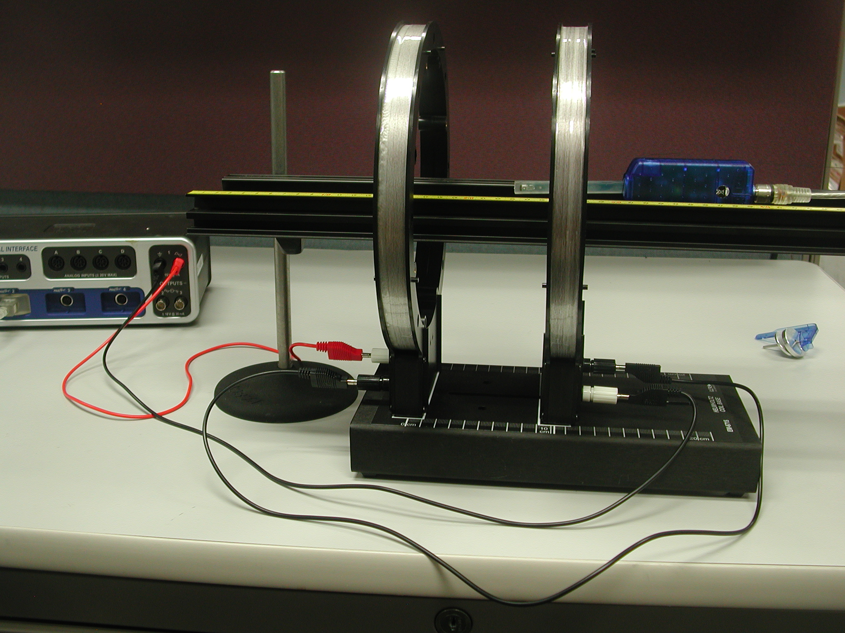 Figure 6: Helmholtz Coil Setup

Helmholtz Coil Setup:

- Attach a second coil to the Helmholtz Base at a distance from the other coil equal to the radius of the coil. Note that you cannot just use the white rectangles on the base since it was designed for the 200 turn coils and the 500 tern coils are have a slightly larger diameter. Make sure the coils are parallel to each other (the white rectangles do help). See Figure 6. The left coil is about 15 cm from the end of the track. Align coils & track as before.

- Connect the second coil in series with the first coil. See Figures 6 & 7. Note that the connectors on the coil all face outward and that the black jumper cable between the coils goes from black connector to black connector. The other black cable goes from the white connector to the black connector on the 850.

- With the DC power off, slide the magnetic field sensor along the track until the end of the Magnetic Field Sensor in the half way between the two coils. Press the tare button. Also, open the properties of the Rotary Motion Sensor in the Data Summary and click on "Zero Sensor Now". This will make zero on the x-axis be at the center between the coils. "Zero on Start" should still be unchecked.
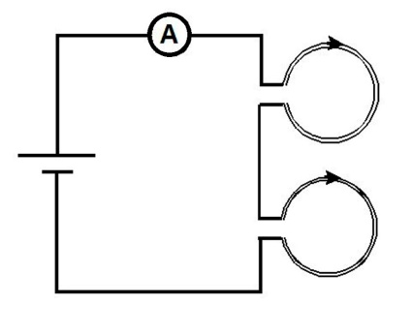

Figure 7: Helmholtz Wiring

Helmholtz Coil Procedure:

- Slide the Magnetic Field Sensor back away from the coils until it is about 15 cm from the first coil. Turn on Signal Generator #1 (15 V). Start recording and slowly move the Magnetic Field Sensor along the center of the track, keeping the probe parallel to the track, until the end of the sensor is about 15 cm past the second coil. Then stop recording.

- Click open Data Summary. Double click on this run and re-label it "Helmholtz Coil".

- Click open the Signal Generator. Click the DC voltage Off. Click Signal Generator to close the panel.

- Click Calculator and verify that line 1 matches Equation 2 from Theory. Change line 4 to match the current shown in the Helmholtz Coil Current box. Change line 5 & 6 to match your measured coil radius (see table on Single Coil page). d from line 6 should be the same as R from line 5.

- Does the theoretical equation fit everywhere? If not, why not?

Two Coils Not at Helmholtz Spacing
- Now change the separation between the coils to 1.5 times the radius of the coils. Repeat the scan. Click open Data Summary and label this run "1.5 R".

- Now change the separation between the coils to half the radius of the coils. Repeat the scan. Label this run "0.5 R".

- How does changing the coil spacing affect the magnetic field?

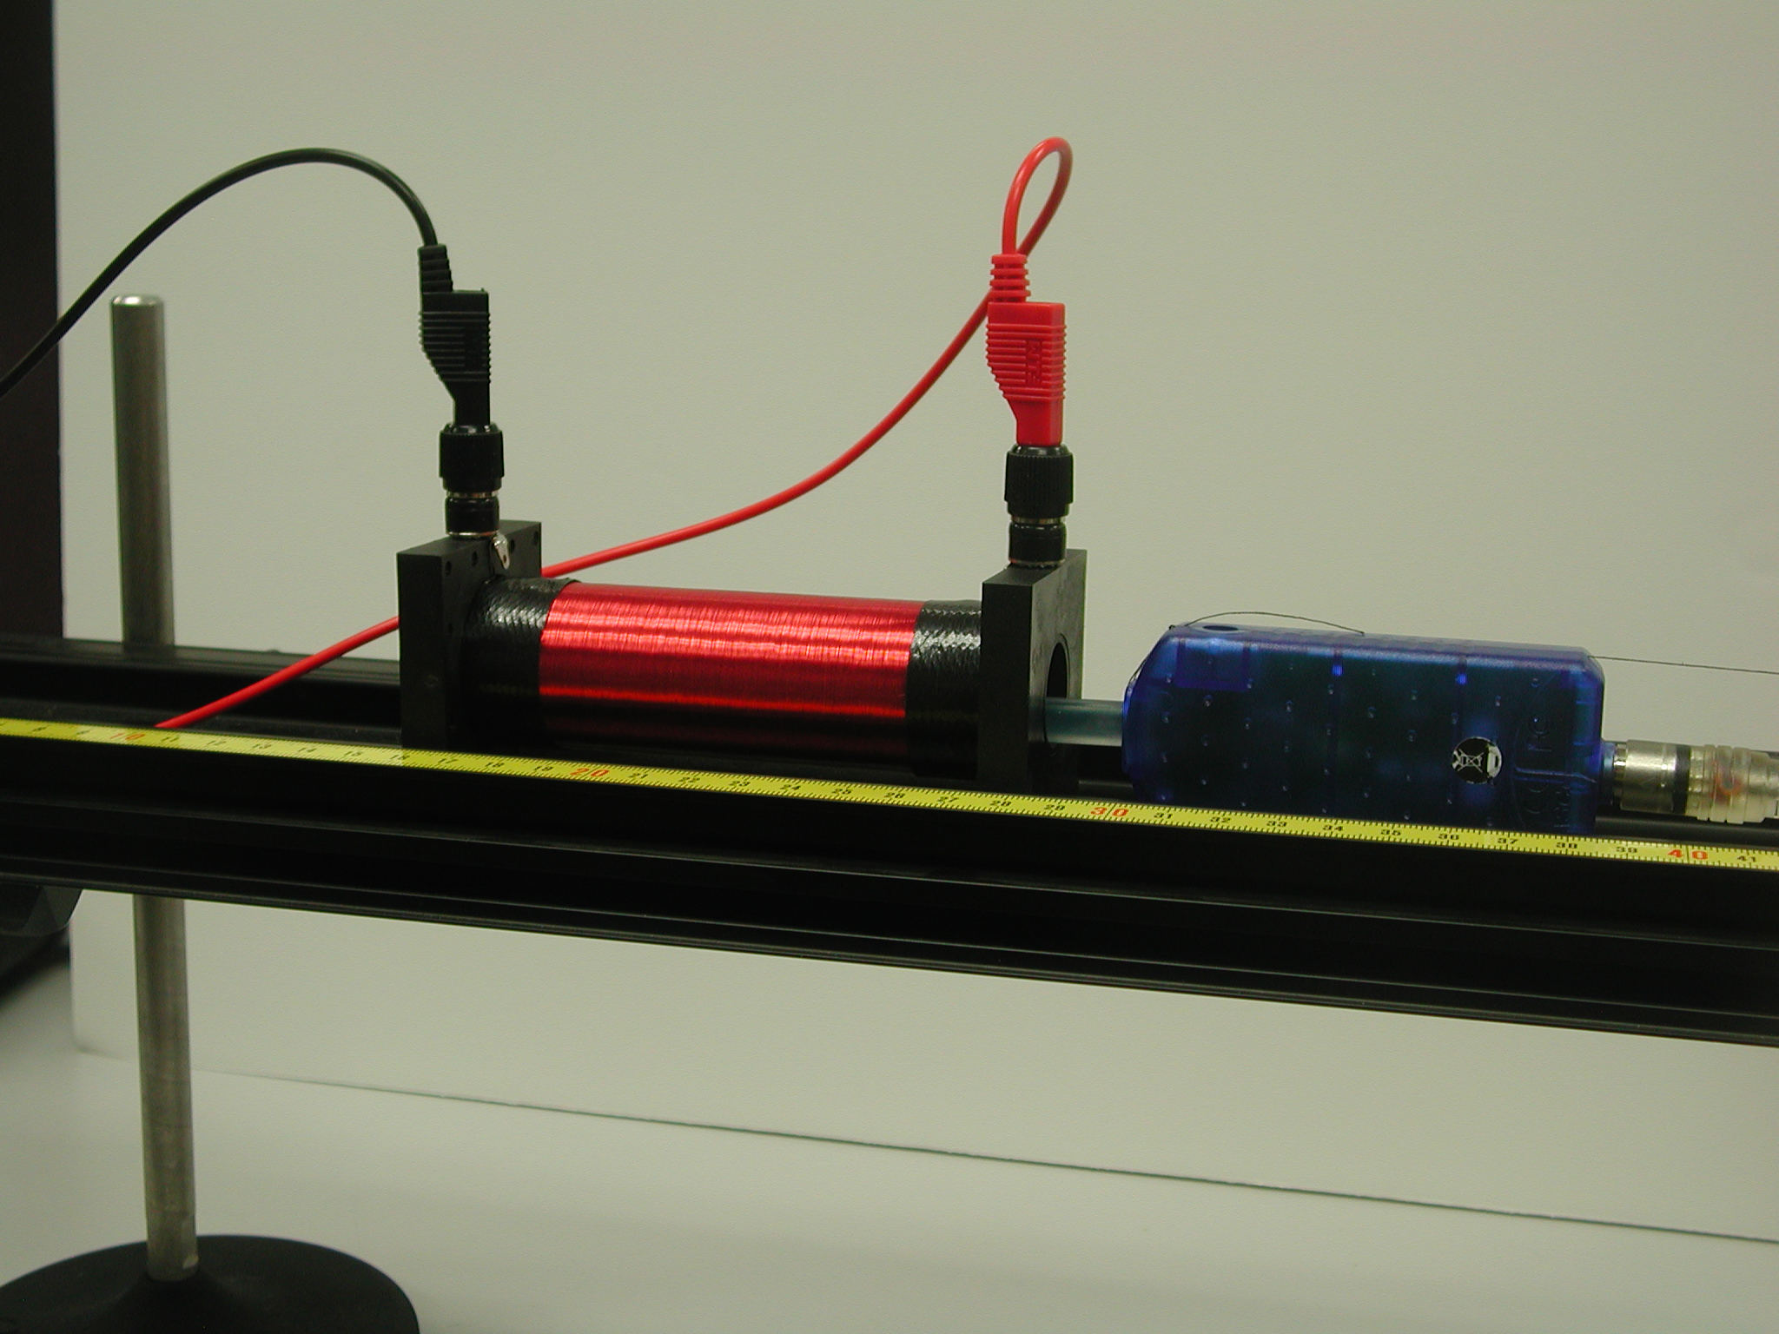 Figure 8: Solenoid Setup

Solenoid Procedure:

- Setup as shown in Figure 8 by setting the solenoid on the optics track. Note that the magnetic sensor probe goes just past halfway thru the coil when fully inserted. The 2-axis Magnetic Field sensor is still connected to the Rotary Motion Sensor.

- Connect the 850 Output #1 DC power to the solenoid.

- With the DC power off, put the Magnetic Field Sensor all the way inside the solenoid. Press the Tare button. Click open Data Summary. Click Rotary Motion Sensor properties and click “Zero Sensor Now”. Click OK. Note the position of the solenoid on the track and try not to move it during the rest of the experiment.

- Click open Signal Generator. Output 1 should be set for a DC Voltage of 1 V. Click the
DC Voltage on. Click RECORD and adjust the DC Voltage until the Solenoid Current reads about 100 mA. Click STOP. Click Delete Last Run. Click the Signal Generator closed.

- Click RECORD. Move the sensor around inside the solenoid staying within a few cm of the center, but moving from the axis to the edge of the coils and back. Click STOP.

- Examine the Central Field graph. Click the Scale to Fit icon. Is the field inside the solenoid the same everywhere?

- Measure the length of the coil (between the end blocks). PASCO specs list the coil as having 2920 turns. Using this information and Equation 4 from Theory calculate the theoretical value of the magnetic field. Click on the black triangle by the Statistics icon and select “mean”. Click on the Statistics icon. The mean value should appear on the left of the graph. Compare this value to the theory value.

- When you go to the next page the program will ask if you want to turn off the Signal Generator. Click “Leave On”.

Solenoid Field:

- Insert the magnetic sensor probe fully into the solenoid.
- Click RECORD. Move the probe slowly out of the solenoid and about 5 cm beyond. Click STOP.
- Note that the sensor is about 7 cm from the body of the 2 Axis Magnetic Field Sensor, so the sensor exits the coil when the position is about 7 cm.
- Is the perpendicular field equal to zero?
- What happens to the axial field as you approach the ends of the coil?
- Does the field go to zero outside the coil?
Magnetic Field across a Single Coil

- Set up the single coil as before except instead of putting the track through the coil, set up the track so it is parallel to the face of the coil. Make sure the elevation of the track is set so the magnetic probe is at the height of the center of the coil.

- Create a graph of the Axial Magnetic Field vs. Position and then add a second plot area for the Perpendicular Magnetic Field vs. Position.

- With the DC power off, slide the magnetic field sensor along the track until the end of the Magnetic Field Sensor in the middle of the coil. Press the tare button. Also, open the properties of the Rotary Motion Sensor in the Data Summary and click on "Zero Sensor Now". This will make zero on the x-axis be at the center of the coil. Also uncheck "Zero on Start".

- Slide the Magnetic Field Sensor back so it is about 15 cm away from the edge of the coil. Turn on Signal Generator #1. Start recording and slowly move the Magnetic Field Sensor along the center of the track, keeping the probe parallel to the track, until the end of the sensor is about 15 cm past the other edge of the coil. Then stop recording.

- Explain the shape and magnitude of the plots of the parallel and perpendicular magnetic fields.

